Business Analytics Portfolio Project:
Retail Sales & Customer Insights Analysis
Name: Mir Fasahat Ali Khan

1. Project Overview:

This project is about analyzing a retail sales dataset to understand the sales performance and customer-related information in the data.
I worked on the project using Excel and MySQL. After analyzing the data, I used Pivot Tables, KPI cards, and a dashboard to present the results in a more simple and visual way.
The main idea behind this project was to take the raw data, analyze it from different angles, and find information that could be useful for understanding the business.

2. Business Problem:

When sales data is available in the form of a large table, it is not always easy to understand what is happening in the business just by looking at the records.
So, in this project, I wanted to use the data to answer some basic business questions and find useful patterns.
Some of the questions I focused on were:

- How much sales are being generated?
- Which products or categories are performing well?
- What can the data tell us about the customers?
- Are there any noticeable patterns in the sales data?
- What are some useful points that a business could take from this analysis?

The purpose was not just to calculate numbers, but to understand what those numbers actually tell us about the business.

3. Project Objectives:

The main objectives of this project were:

1. To understand the sales data and get an overall idea of business performance.
2. To find useful patterns and trends in the data.
3. To use SQL to answer the given business questions.
4. To use Excel for calculations and data analysis.
5. To use Pivot Tables to summarize the data and make comparisons easier.
6. To create KPI cards for the important numbers.
7. To create a dashboard that shows the main results in one place.

4. Dataset Description:

For this project, I worked with a retail sales dataset containing information related to sales and customers.
I first went through the dataset to understand what information was available and how the different fields could be used. I then used the data for both Excel and SQL analysis.
Instead of looking at the data only as individual records, I tried to summarize it in different ways so that it would be easier to identify patterns and compare different parts of the business.

5. Tools Used:

Excel

I used Excel to work with the dataset, perform calculations, and explore the information. I also created Pivot Tables to summarize the data and make it easier to compare different values.

MySQL

I used MySQL to write and run SQL queries. The queries were used to answer the business questions and get the required results from the dataset.

Pivot Tables

I used Pivot Tables to group and summarize the data. This helped me look at the information from different perspectives without having to manually calculate everything.

KPI Cards

I created KPI cards to show some of the important numbers from the analysis. The purpose was to make the main figures easy to see without going through the entire dataset.

Dashboard

I created a dashboard using the results of my analysis. The dashboard brings the important KPIs and charts together so that the overall results can be understood more quickly.

6. My Analytical Process:

I followed a simple step-by-step process while working on this project.

Raw Data → Excel → MySQL → Pivot Tables → KPI Cards → Dashboard → Insights

I started by looking through the raw dataset and understanding the information available. I then used Excel to work with the data and MySQL to answer the SQL-based business questions.

After that, I created Pivot Tables to summarize the information and make comparisons easier. I used the results to create KPI cards and build the dashboard.

Finally, I went through the results and looked for the main points and patterns that could be useful from a business perspective.

7. Excel Analysis:
7.1 Excel Data Analysis

I used Excel to analyze the dataset and understand the information in a simpler way. First, I worked with the data by sorting and filtering it and then used different calculations to summarize the results. I also created Pivot Tables for different questions to identify useful patterns and trends in the data. The results from Excel were then compared with the SQL analysis to get a better understanding of the overall findings.

7.2 Pivot Table Analysis

I created Pivot Tables in Excel to answer five different questions based on the dataset. These tables helped me summarize the data and identify the required result without having to go through the entire dataset manually. The results obtained from the Pivot Table analysis are shown below.

Questions | Results
Region with the Lowest total sales | East
Product with the highest total sales | Laptop Pro 15
Total Profit generated | $65,590.80
Revenue given up through discounts | $24,831.90
7.3 KPI Cards

I also created a few KPI cards in Excel to get a quick idea of the overall results. These cards show some of the main figures from the dataset, such as sales, profit, orders, and discounts. This made it easier to look at the important numbers in one place and understand the overall performance of the data.
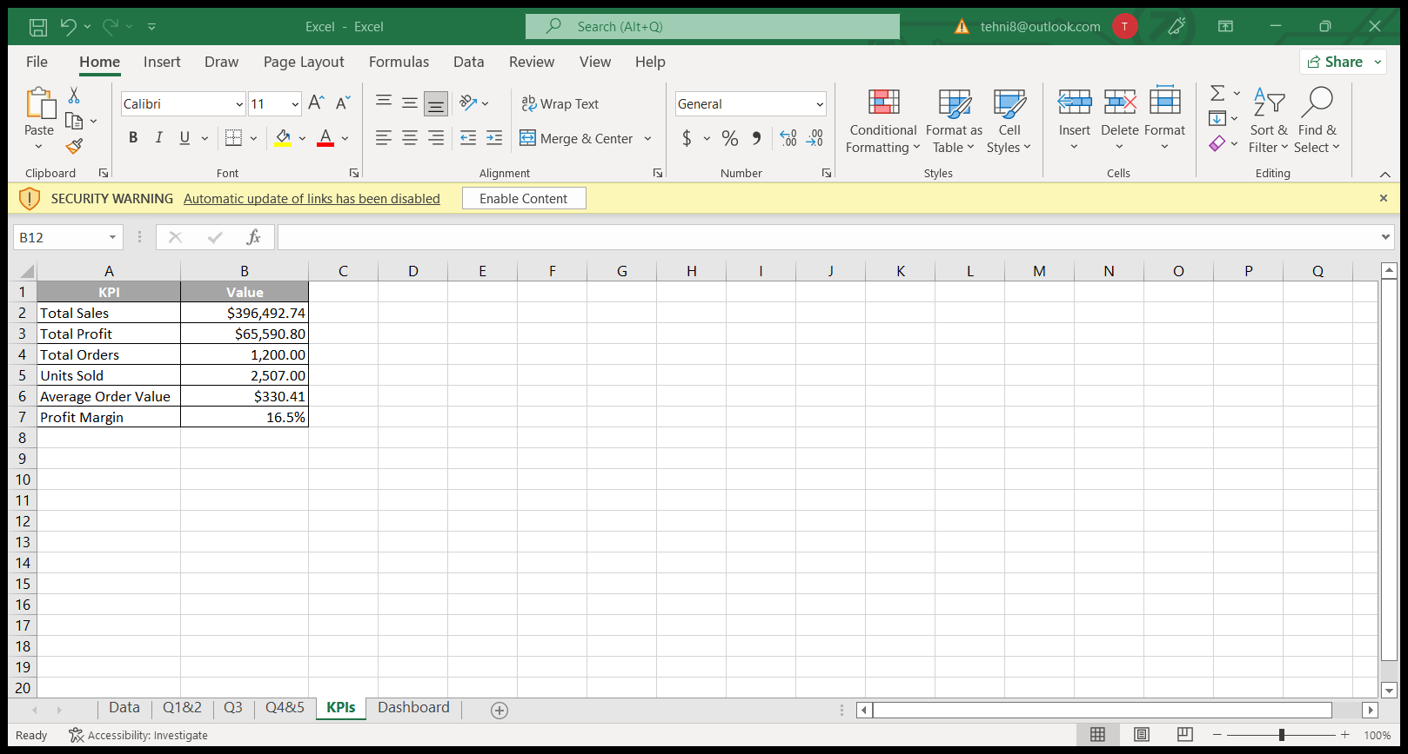

Figure 7.1: KPI summary created in Excel

7.4 Excel Dashboard & Charts

I made an Excel dashboard to put the main results of my analysis together in one place. It shows the important numbers at the top and includes charts for sales by region, sales by category, customer segments, and monthly sales. I also added a few key points at the bottom to make the main findings easier to understand.

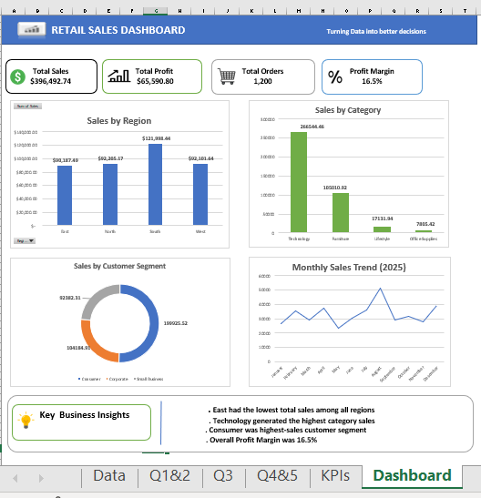
Figure 7.2: Excel dashboard showing the analysis and key findings

7.5 Key Findings
From the Excel analysis, I was able to identify a few important points from the dataset. The East region had the lowest total sales, while the Technology category had the highest sales. The Consumer segment contributed the highest sales among the customer segments. The total profit was $65,590.80, with an overall profit margin of 16.5%. These findings helped me understand the sales and profit performance of the business more clearly.

Key Finding | Result
Lowest sales region | East
Highest sales category | Technology
Highest sales customer segment | Consumer
Total profit | $65,590.80
Profit margin | 16.5%

8. SQL Analysis:
8.1 SQL Data Analysis
I used SQL to work with the dataset and find answers to different business questions. I used queries to filter, group, sort, and calculate the data where needed. This helped me find useful information about sales, orders, products, and profits. I also compared the SQL results with the analysis I did in Excel.

8.2 SQL Queries
I wrote SQL queries to answer five questions using the retail sales dataset. The queries were mainly used to group the data, calculate totals, count orders, and sort the results to find the required answers.
Query | Business Question
Q1 | Which region has the lowest total sales?
Q2 | Which products has the highest total sales?
Q3 | On which date were the highest number of orders placed?
Q4 | What is the total profit generated?
Q5 | How much revenue was given up through discounts?

Q1 Lowest total sales by region
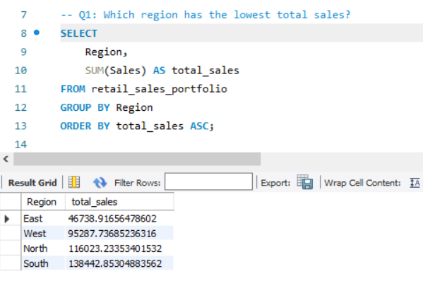

Q2 Which products has the highest total sales?
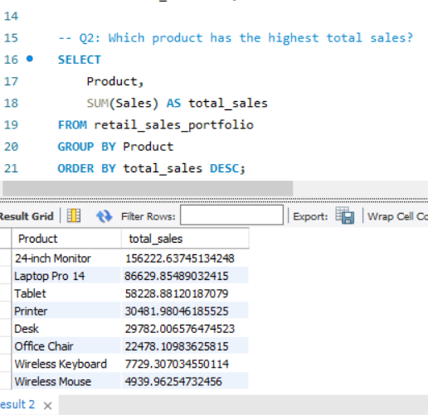

Q3 On which date were the highest number of orders placed?
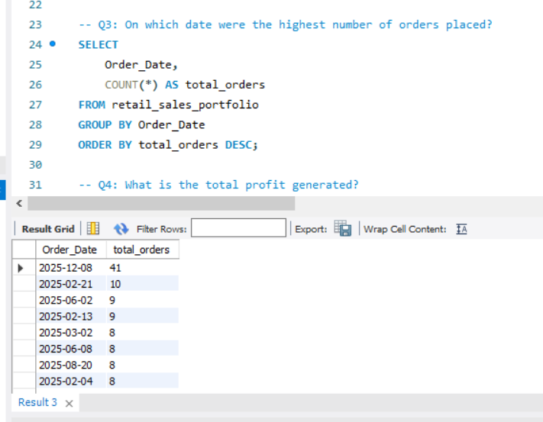

Q4 What is the total profit generated?
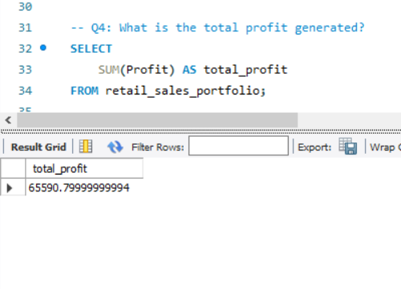

Q5 How much revenue was given up through discounts?
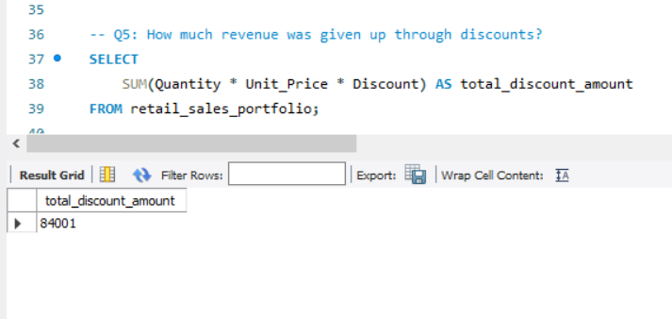

8.4 Key Findings from SQL
After looking at the SQL results, I was able to identify the main results from the dataset. The East region had the lowest total sales, while the Laptop Pro 15 had the highest total sales among the products. The highest number of orders was recorded on 8-Dec, with 41 orders. The total profit was $65,590.80, and the total amount given up through discounts was $24,831.90.

9. Business Insights / Findings:

- The East region had the lowest sales, with total sales of around $90,187.49. The South region had the highest sales among the four regions.
- Looking at the categories, Technology had the highest sales.
- When comparing the customer segments, Consumer customers generated the most sales, with $199,925.52 in sales. Corporate customers generated $104,184.91, And Small Business generated $92,382.31.
- The total profit from the dataset was $65,590.80. The overall profit margin was 16.5%.
- There were 1,200 orders in the dataset, with total sales of approximately $396,492.74.

10. Recommendations:
Based on the analysis, I would recommend:

- Focus on improving sales in the East region.

- Continue focusing on the Technology category.

- Maintain strong customer engagement with the Consumer segment.

- Keep discounts under control to protect profit.

11. Conclusion:

Overall, this project gave me a good understanding of how Excel and SQL can be used to work with business data. I was able to analyse the data, find patterns in sales and profit, and present the results using charts and tables. It also helped me get more comfortable with using data to answer basic business questions.

12. Skills Used:
- Microsoft Excel
- MYSQL
- Data Cleaning
- Data Analysis
- Pivot Tables
- Data Visualization
- Dashboard Creation
- Business Insights

13. Project Summary:

In this project, I worked on a sales dataset and tried to understand what was happening in the business through the data. I used Excel and SQL to analyse the data and created different tables, charts and a dashboard to make the results easier to understand. I also looked at things like sales, profit, customers and regions. Overall, this project helped me get some practical experience with Business Analytics and understand how data can be used to find useful information.

